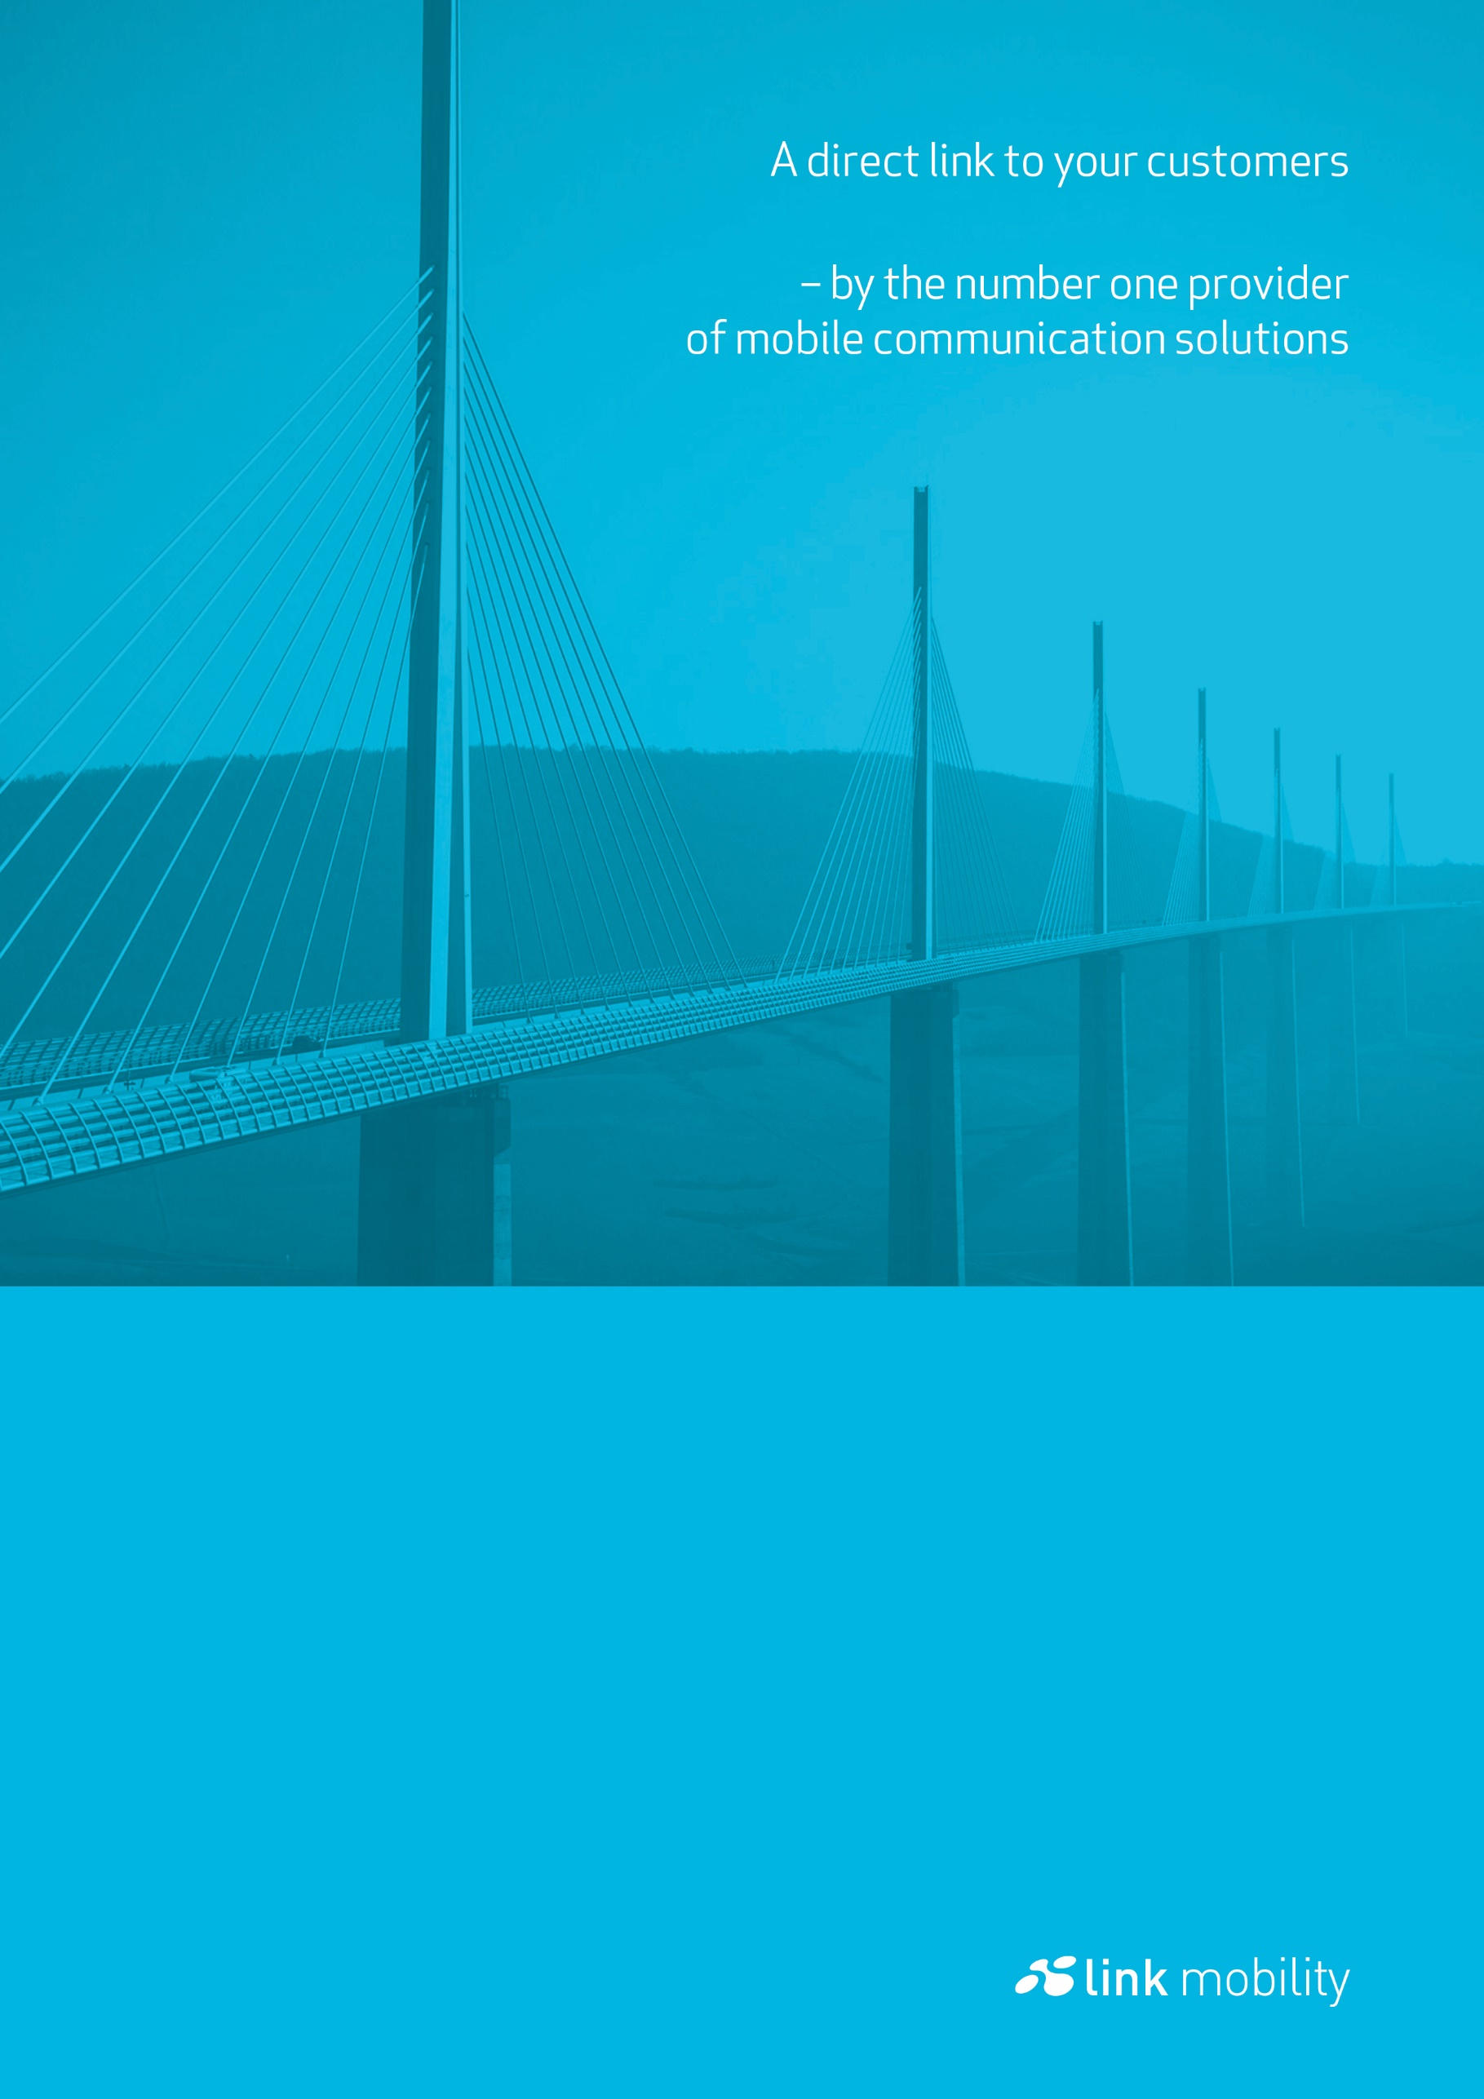

LINK Mobility Email2SMS

Version 5.3; Last updated September 22, 2022

For help, see the following link https://linkmobility.com/support/

The most up-to-date version of this document is available at   
https://www.linkmobility.com/developer/

Contents

Email2SMS 3

Parameters 3

Changelog of this document 4

# Email2SMS

This system uses standard email for sending sms and has an intuitive user experience for those used to sending emails. The mobile number will prepend the email suffix **@sms.sp247.net**.

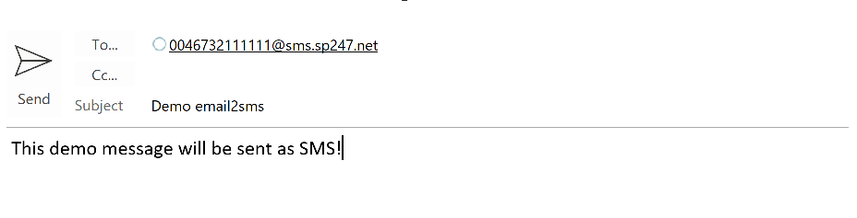Figure 1, SMS is sent to 0046732111111

## Parameters

|  |  |  |  |
| --- | --- | --- | --- |
| **Field** | **Case sensitive** | **Required parameter** | **Description** |
| To address | No | Yes | The recipients’ mobile number as part of an email address * |
| From address | No | Yes | Customer email address which maps against the customer’s profile |
| Subject | No ** | No ** | Description of sending. If not set, default message from customer profile is used ** |
| Body | No | Yes | The SMS message being sent |

* Supported mobile number formats include:

+46732111111 (MSISDN)

0046732111111

0732111111 (National format, only supported in limited markets)

** Based on customer specific profile; subject can be used to change sender text, indicate bidirectional communication or as a customer’s unique case sensitive key

# Changelog of this document

|  |  |  |  |  |  |
| --- | --- | --- | --- | --- | --- |
| Date | Version | | Author | Changes | |
| 2019-05-07 | 1.0 | | JS | Initial version | |
| 2021-02-19 | | 5.1 | TL | | The URL for developers, From HTTP to HTTPS |
| 2021-04-29 | | 5.2 | TL | | Changed to new homepage URL |
| 2022-09-22 | | 5.3 | JS | | Changed support email to support URL |